3P Rainforce 350H

Installation & Operating Manual

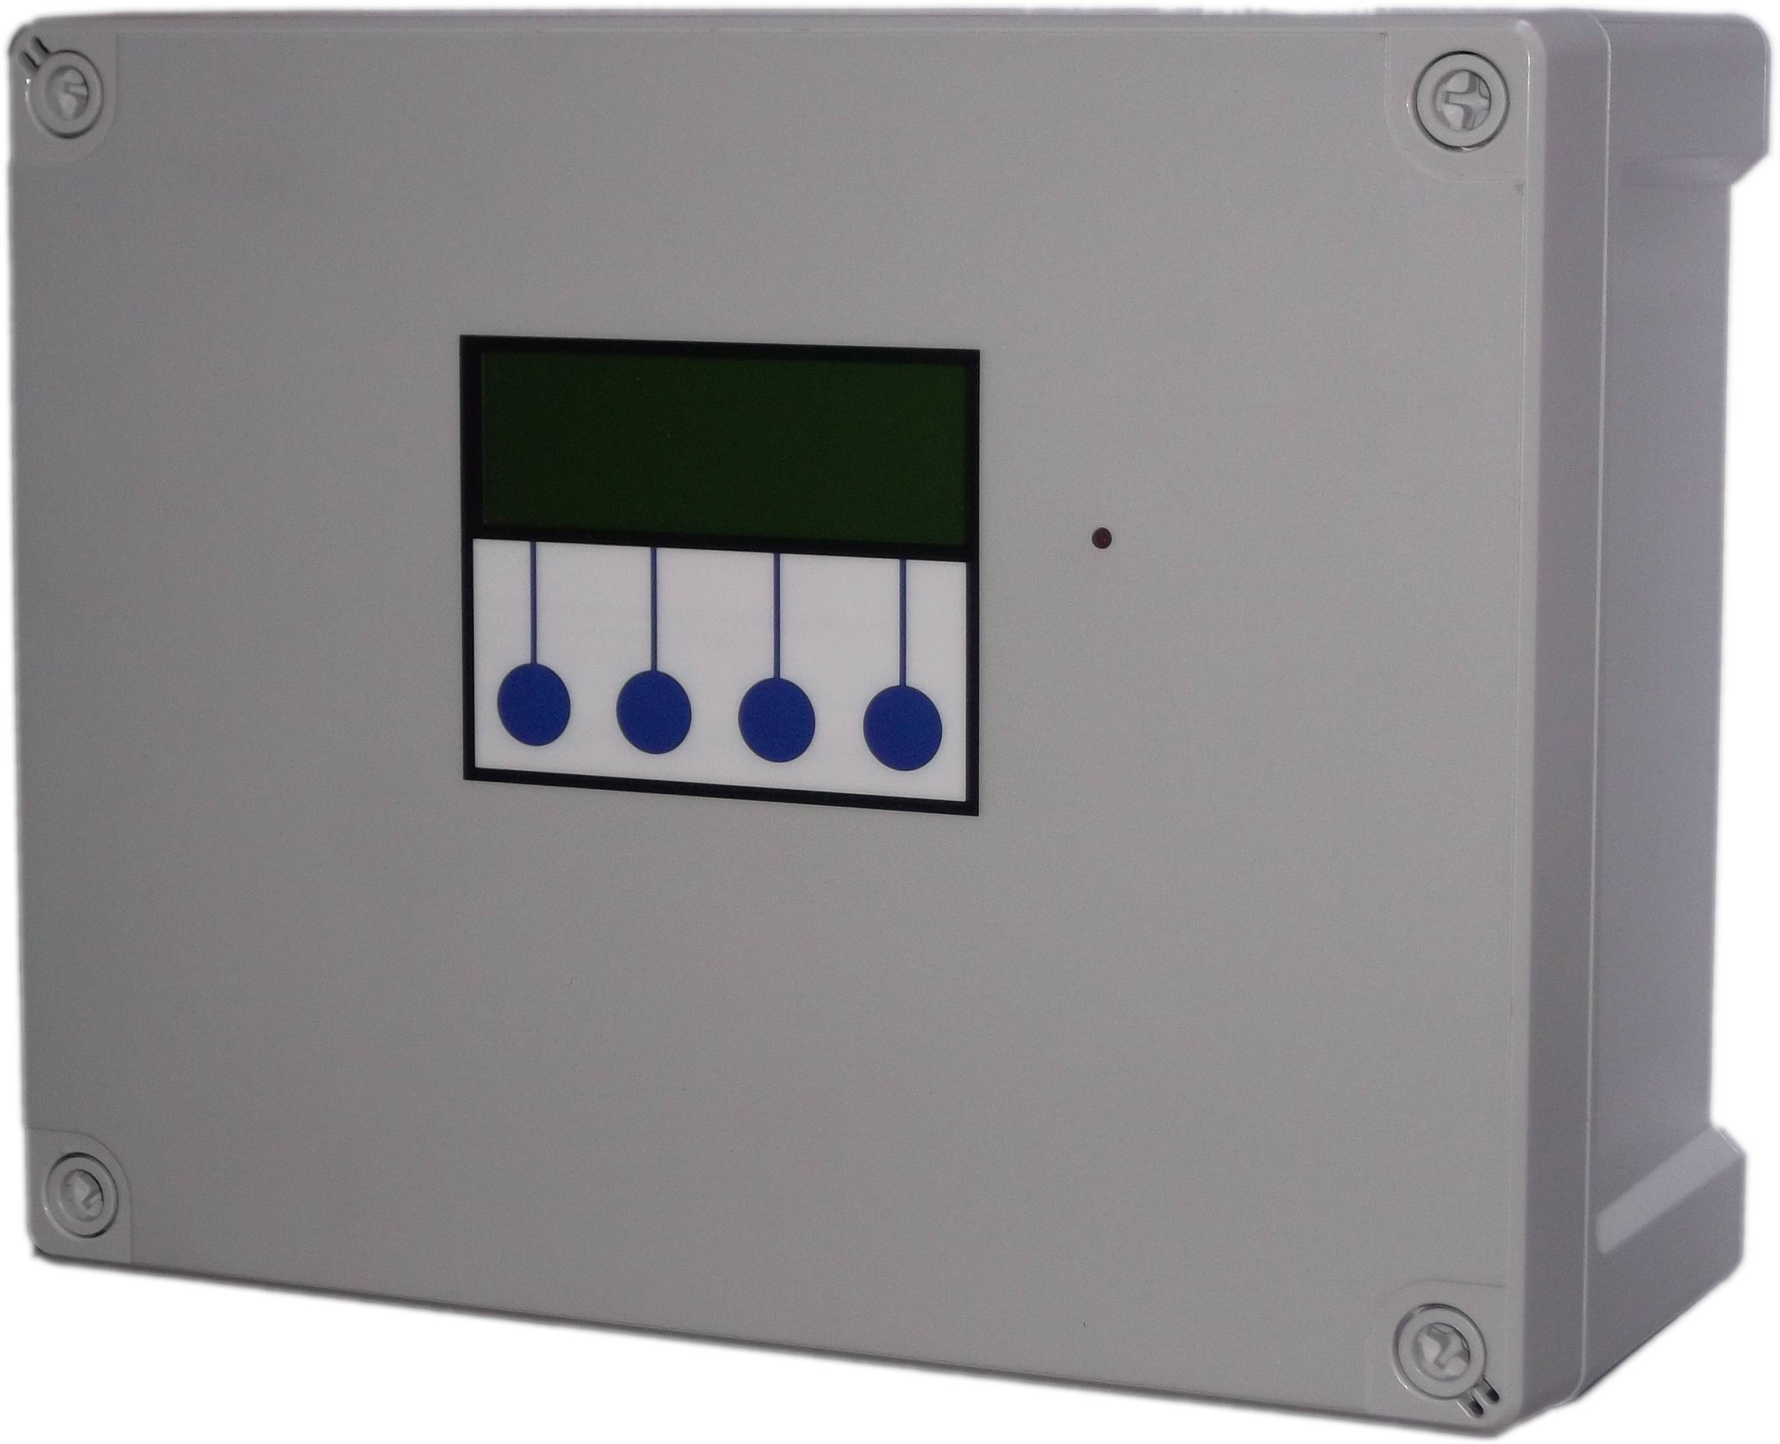

Installation

Safety
Mains Voltage – There are exposed electrical conductors inside this appliance. This appliance must be installed and serviced by a competent electrical technician to the current requirements of BS7671 and IEEE recommendations. Before servicing this appliance, normal safe isolation procedures should be implemented.
Do not touch the PCB while energised, it carries mains voltage.

Do not touch any connection terminals while energised.

Do not attempt to service this item when wet, or in a wet or high humidity environment.

If the housing of the control panel becomes damaged, you must shut down and securely isolate this appliance immediately.

You must connect this appliance to a grounded 3 wire supply, protected by suitable overload protection. Connected pumps and solenoids are earthed via the control panel, and may otherwise become live.

If the power cables are damaged, either to of from the controller then shut down and isolate this appliance.

The combined loading of pumps and solenoids connected t this appliance must not exceed 20A using the supplied mains flex. Contact the manufacturer for advice if you need to exceed this rating.

Do not attempt to repair any part of the circuit board. Refer to the manufacturer for advice.

Included Components
1 x Control Panel
1 x 2m Mains Flex 2.5mm
4 x header/day tank level sensors – connected to junction box
1 x 20m multicore cable for header/day tank connection
2 x Pressure transmitter with 20m cable

Layout
Unlike other wall mounted controllers, the 3P RainForce does not contain a pump, solenoid, or mains top-up unit, these items are external to the control panel. This means you can install the control panel anywhere you wish within the building.

You will need to consider the following constraints,

The control panel cannot be mounted outside, it is not weather resistant.
Don't use it as a junction box to join up other miscellaneous cables in the plant room.
Don't re-route the cables over the surface of the circuit board. Parasitic interference from mains voltages close to the logic circuit will cause unreliable operation. It was designed for power cables to exit the bottom of the unit. Use external trunking if necessary to route cables.
Voltage drop will affect the cable size needed to take power to your pumps. Over very long runs, you may find it more economical to install contactors near to the pumps, allowing you to control the pumps with a sensible cable size. It is strongly recommended that you calculate voltage drop for cable runs in excess of 20m. Failure to do so may result in cable overheating, conductor migration, and risk of fire.
Also note that all control cabling (sensor and switch wiring) beyond a few metres and installed in electrically noisy environments may need to be shielded to avoid false switch detection or unstable level readings. Note – it is recommended that you earth the shielding on cables (where present) to an earth terminal within the controller. Do not earth to DC 0v as the DC power supply is isolated and will not function as a ground.
Do not install control cabling next to mains power cables, particularly over long distances. Adequate separation from power cables will reduce potential problems. Where control cabling must cross mains wiring it should be done at right angles and kept to a minimum.
We do not make any recommendation as to the specific cable or layout to be used. It is the responsibility of the installer to install control cabling appropriately giving consideration to length and proximity to electromagnetic noise.
It is expected that the installer is suitably competent with regard to electrical installation, and the provisions of and testing in accordance with the current regulations in force in your area. It is also expected that the installer is competent to install, validate and resolve any issues with regard to control cabling.
In the event of unresolved interference to switch inputs, it is possible to create a separate powered sensor circuit at low voltage operating relays near to the control panel to act as inputs. This will have much higher immunity to parasitic voltages than the transistor based inputs on the control panel.
Most instability of the level sensor caused either by interference or turbulence in the water itself can be compensated in software by adjustment of the probe stability setting.
Pressure transmitter cable is of a special type incorporating a vent tube to equalise the pressure within the transmitter to atmospheric pressure (3P part no. IRVENT or IRVENTX depending on type). The vent should terminate in a dry location. If not then it must be extended in vented cable to a suitable location, or terminated in a sealed terminal head with moisture resistant vent.
All systems involving a header/day tank situated inside the building envelope should include a sufficiently sized overflow.

Control Panel Mounting
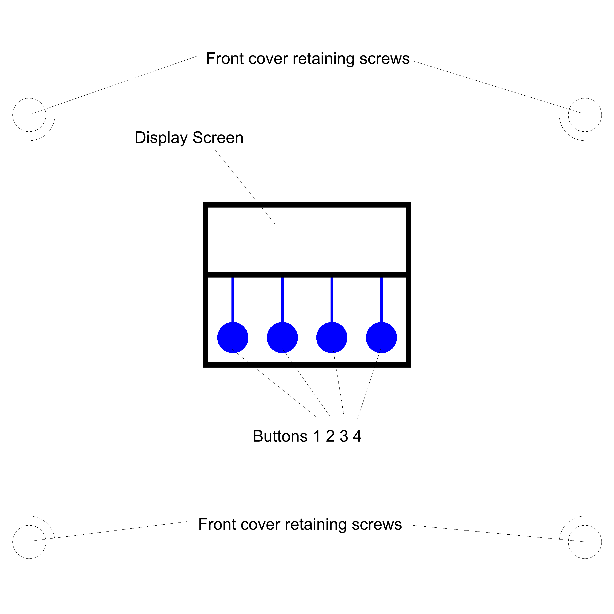Method 1 - Use the mounting brackets provided.

Method 2 - Having selected a suitable location, unlock the 4 locking screws on the corners of the front cover and withdraw the front panel. The LCD display, buttons and alarm LED are connected to the PCB. Remove and re-plug these cables afterwards if necessary in accordance with the diagram.

The 4 screw mounting holes are located on the main enclosure in recesses adjacent to the front panel mounting holes. Mark drilling points on the wall accordingly. Withdraw the casing from the wall and drill holes appropriate for your selected fixings.
Mains Power Connection
The power supply to the control panel enters via a cable gland on the bottom right of the housing. Insert the cable, connect to the incoming power terminal on the right of the PCB, and tighten the cable gland.

Pump Power Connections
Pumps are powered from the rightmost green terminals on the lower right of the PCB. From left to right terminal 1 supplies pump1, and terminal 2 supplies pump2, both situated in Tank 1. Terminal 3 supplies pump 3 and terminal 4 supplies pump 4. These may either supply single phase pumps directly up to 10A, or 3 phase pumps via external contactors, or single phase pumps over 10A via external relays. The terminal blocks are socketed and can be withdrawn from the PCB for ease of access.

Header/Day Tank Sensor Installation and Connection
There are 4 header/day tank sensors.

Sensor 1 – Low level sensor
Sensor 2 – Mid level sensor
Sensor 3 – High level sensor
Sensor 4 – Overflow alert sensor

Sensors are installed in the header/day tank in line from bottom to top, and should be installed such that they sit horizontal with the toggles flapping upwards (circuit closed when no water).

Before drilling the header/day tank and fitting these sensors, please consider their function in order to locate at the appropriate spacing. In normal use (Eco mode) the controller will try and maintain water level between the mid and high levels.

Sensor 1 detects the header/day tank being out of water, and should normally be installed just above the supply outlet level of the header/day tank.

Sensor 2 determines the point at which the pump or will be activated to replenish the header/day tank. It is therefore prudent to allow sufficient space between the mid and low level sensors to maintain a reserve suitable for handling peak demands which may exceed the delivery rate of the pump or solenoid.

Sensor 3 determines the maximum fill level of the header/day tank and should be installed as high as possible beneath the overflow, whilst still allowing space for the overflow alert sensor.

Sensor 4 should be installed just below the overflow height, and will provide overflow alert and system shutdown in the event of a potential overflow, usually preventing an overflow condition before it occurs.

In considering the placement of the sensors, a judgement must be made as to the location of Sensor 2 (the mid level sensor). The higher this is placed, the more water will be available as reserve for peak demands, and the pumps will activate more often. The lower it is placed, pumps will activate less frequently (and for longer duration) thus increasing component lifespan, but as water will fall to a lower level before being replenished, less is available for peak demand.

To install the sensors, mark and drill holes as appropriate on the header/day tank using a 16mm bit. Remove the back-nut from each sensor and install from the inside wall of the tank, with the toggle free to move downward (it must flap down, not up). Re-attach the back-nut.

Sensors are then to be connected to the 10 pin plug on the bottom left of the PCB marked “inputs” using the shielded cable provided, in the following order.

Low level sensor – Pins 3 and 4
Mid level sensor – Pins 5 and 6
High Level Sensor – Pins 7 and 8
Overflow sensor – Pins 9 and 10

Pins 1 and 2 are unused on this model
Polarity is unimportant.
Note – If cables need to be routed into the controller other than with the cables glands fitted, ensure they enter the bottom of the casing and do not cross over the circuit board. If necessary use trunking to route cables appropriately.

Rainwater tank level sensors and connection
Connect the tank level sensor as follows

Pressure Transmitter 1 (tank1) - Connect to the socket on the underside of the control panel.
Pressure Transmitter 2 (tank2) - Connect to the socket on the underside of the control panel.

The pressure transmitters should be lowered onto the bottom of the rainwater tank and not suspended.

DO NOT test the input by shorting the pins

BMS connection
The BMS connection provides a non-voltage relay capable of switching any 230V source up to 10A. Three contacts are provided, Common, NO and NC. Connect your live conductor from the BMS system to Common, and output will be switched to NC in the absence of an alarm condition, switching to NO upon an alarm.

Troubleshooting
Refer to the Safety instructions. No electrical works should be carried out other than by an appropriately qualified Electrician. Permits to work may be required at local site conditions. If in any doubt, consult your system supplier.

Problem
Probable Cause
Solutions
No Power – controller dead – no backlight on LCD
No power supply from distribution board

Fuse failed

PCB damaged
Check 240 vac 50hz supply at power input terminals.

Check Fuse F1

Replace PCB, contact manufacturer.
Backlight on – no display – no operation
MCU chip missing

MCU chip badly inserted or bent pins

MCU chip wrong way round

MCU chip faulty

PCB damaged
Insert MCU

Insert MCU correctly or replace if necessary

Remove and re-insert correctly

Replace MCU

Replace PCB, contact manufacturer.
Controller Frozen – operates normally but keypad unresponsive
Keypad not connected or connected wrongly
Check connection
Controller Frozen – does not operate normally
MCU or oscillator damaged
Replace MCU, if no success replace PCB
Tank level sensor does not function (error 6)
Not connected

Connected wrongly

Sensor faulty

Input circuit faulty
Check wiring to controller

Check wiring polarity and correct if needed

Test with current loop calibrator, replace sensor if necessary

Test with current loop calibrator, replace PCB if necessary
Tank Level sensor reads incorrectly
Cable vent tube blocked or sealed

Wrong sensor specification installed

Sensor faulty
Ensure vented section of cable terminates to atmospheric pressure

Replace with original OEM spec part

Test with loop calibrator, replace if necessary
header/day tank sensor fault (errors 3,4,5)
Faulty or disconnected sensor

Faulty multicore cable or connection

Parasitic interference upon multicore cable from nearby power supply cables.

Faulty input on control panel

Sensor installed wrong way up.

Sensors installed out of sequence
Verify with continuity test, replace if necessary.

Verify with cable tester. Rewire or replace if necessary.

Ensure separation between control cables and power cables, verify cable shielding is earthed at one end only.
Insert temporary jumper link to verify. Replace PCB if necessary.

Toggle should tilt upwards, rotate sensor to fix.

Check inputs using diagnostic menu. Swap inputs to fix.

Check inputs using diagnostic menu. Swap inputs to fix.
header/day tank overflow detected (error 10)
Sensor installed wrong way up

Sensor installed too low

High level sensor failure causes overflow

Solenoid stuck open
Check orientation, toggle should hang upwards.

Relocate above other sensors

Test and replace sensor

Isolate power, test and replace solenoid
Pump Insufficient or Faulty
Pump not connected

Pump cannot keep up with demand

Pump faulty
(this fault can show temporarily when filling a large header/day tank for the first time, in which case it should be ignored).
Check wiring

Replace with correctly sized pump

Replace pump
Pump Disabled
Pump not connected for over 120 minutes

Fuse failed on output

Pump cannot keep up with demand for over 120 minutes

Pump faulty (most likely)
Check wiring

Check and replace if necessary

Replace with correctly sized pump

Replace pump

Note – References to loop calibrator refer to a current loop calibrator 4-20mA, NOT a loop impedance test.

Fuse Listing
F1 – 500mA 20mm quick-blow
F2 – 1A 20mm glass passivated
F3 – 10A 20mm glass passivated
F4 – 10A 20mm glass passivated
F5 – 10A 20mm glass passivated
F6 – 10A 20mm glass passivated

Inputs (left to right) – Con1
1 – Unused
2 – header/day tank Low Level Sensor
3 – header/day tank Mid Level Sensor
4 – header/day tank High Level Sensor
5 – header/day tank Overflow Sensor

Pressure Sensor Inputs (left to right)
Con3 (left) – Rainwater tank 1 level sensor
Con4 (right) – Rainwater tank 2 level sensor

BMS Output
Type – Non contact relay
Terminals – Common, Normally Open, Normally Closed
Power Rating max 10A 230Vac

Pump Control Outputs (left to right)
1 – Pump1 (tank1)
2 – Pump2 (tank1)
3 – Pump3 (tank2)
4 – Pump4 (tank2)

Operation

Safety Considerations
Mains Voltage – There are exposed electrical conductors inside this appliance. This appliance must be installed and serviced by a competent electrical technician to the current requirements of BS7671 and IEEE recommendations. Before servicing this appliance, normal safe isolation procedures should be implemented.
You must connect this appliance to a grounded 3 wire supply, with suitable circuit protection. Connected pumps and solenoids are earthed via the control panel, and may otherwise become live.
If the power cables are damaged, either to or from the controller then shut down and isolate this appliance.

The combined loading of pumps connected to this appliance must not exceed 20A using the supplied mains flex. Contact the manufacturer for advice if you need to exceed this rating.
Do not attempt to repair any part of the circuit board. Refer to the manufacturer for advice.
Description of Operation

The 3P RainForce H Series is an advanced Rainwater Manager, specifically designed to manage the supply of water from an underground rainwater harvesting tank to a header/day tank situated within the building. Like all of the RainForce commercial controllers it has been designed to prioritise the maximum availability of water (preferring rainwater where possible) with minimal power consumption, whilst keeping possible points of failure to a minimum.

Functions within the Control Panel are all menu driven, and menu options are displayed on screen. All adjustable settings are available from the menu structure.
The last (bottom) line of the display screen always shows up to four Menu Options, which can be selected by pressing once on one of the four corresponding Buttons beneath the display description . The Menu Options displayed will change (or toggle) as you enter different areas of the software.

Description of Operation
RainForce 350H is designed to manage the supply of rainwater from 2 rainwater harvesting tanks to a single break tank/header/day tank. Note that unlike the 300H this version does not manage the top-up of mains water into the header/day tank, that function must be installed independently.

Up to 4 pumps can be controlled (2 per tank) operating as either single pump, single pump with redundant spare as standby, twin pump duty assist/standby, or twin pumps always operated simultaneously.

Rainwater will be pumped from one rainwater harvesting tank to the header/day tank as needed. The rainwater tank with the highest percentage of water available will be selected automatically. This ensures both tanks retain equal relative capacity for the capture of new rainwater, and hence maximises the amount of rainwater harvested. A differential of greater than 10% between the two tank levels will prompt the system to automatically switch to the fullest tank.

Water will usually be pumped when the level in the header/day tank reaches a mid level, and will then continue until full. Additionally a more aggressive strategy is available which will keep the header/day tank full at all times, although with a much greater number of pump start-ups being necessary to achieve this.

Duty assist operation activates in the event of the header/day tank reaching a low level, both pumps in the rainwater tank being pumped from will be used simultaneously.

Pump failure is detected by a timing function, and has been optimised for use with day tanks in which the pumps cannot keep up with demand during the day.

During a short circuit or pump overload, only the fuse for the faulty pump circuit will fail. The system will continue to operate with it's remaining pumps.

In the event of either a potential header/day tank overflow, a failure of a header/day tank sensor, or a failure of a rainwater tank level sensor the system will halt. There is no option to override this. Normal operation continues as soon as the fault is removed. The disconnection of any sensor cable produces the same result.

All settings set during configuration are stored in non-volatile memory upon the MCU chip itself and are updated in real time as the configuration is set or data is acquired. There is no backup battery needed.

Note that a header/day tank overflow may still occur if the mains top-up system (not controlled by this controller) fails. We recommend using a mains top-up controller with adequate overflow prevention system, as well as a sufficiently sized overflow pipe.

Control Panel Operations

The Control Panel is a simple interface with a four line LCD and 4 Menu buttons below:

Start Up Screen Menus and Functions

Upon first applying power, the LCD panel will display a start-up Message followed by automatic calibration of the rainwater tank sensor for approximately 3 seconds. It will then immediately commence operation.

Rain 22% 80%
header/day Tank Ok
Pumps off
Menu Eco Stop

Line One The main screen displays the Rainwater Level, shown as either a % (300H) or simply as OK or Empty (100H/200H). See below.
The header/day Tank Status is shown in Line Two. See below.

Rainwater Tank Status
This is the default screen which starts upon power-on, it displays the status of the 2 rainwater tanks, header/day tank, pump activation, header/day tank filling strategy, and the presence of any faults detected if they should occur.

Pump control is only active when this screen is shown and so this is the screen in which the control panel should be left while the system is operating. Following a power outage the system will always default back to this screen regardless of what operations were being performed in other menus prior to the power outage.

Rainwater Level Display
The current rainwater level will be shown in %, and is measured by a submerged pressure sensor at the bottom of the rainwater tank. The scale is adjusted automatically as the control panel learns the maximum and minimum rainwater levels within the tank, with 0% being the minimum rainwater level allowed (60cm by default, adjustable) and 100% being the highest water level detected so far. Initially therefore, the display will be inaccurate until the system self calibrates with changes in rainwater tank level. This self calibration does not affect other level related functions such as top-up level, etc.

Rainwater Tank Status
The current rainwater tank status is displayed either as “OK” or “Empty”.

Header/Day Tank Status
The condition of the header/day Tank is shown as either “Low”, “OK”, or “Full” depending on the water level within the header/day tank.

Menu Options
The last (bottom) line of the Start Up Screen display shows four Menu Options, which can be selected by pressing one of the four corresponding blue buttons beneath the display. These Modes are described below.

Start Up Screen, Buttons 2, 3 and 4: Operational Modes
The Operational Mode options are reached via these three (of four total) buttons beneath the LCD display. The options displayed will change as you enter different areas of the software.

Header/Day Tank Filling Strategy (Eco/Max) – Button 3
From the Start Up screen, Button 3 allows you to choose between “Eco Mode” and “Max Mode”. Eco Mode is set by default and should be used for most purposes. In Eco Mode the header/day tank is filled when the water level falls to the mid level switch and continues to fill until the high level switch is reached.

Max Mode keeps the header/day tank topped up to its maximum level at all times, which may be useful if you are expecting a scheduled power cut, or if you are expecting or experiencing large instantaneous demand(s) for water.

Where 2 pumps per tank are fitted, both pumps will be operated when the water level falls below the low level switch and will remain on until the tank is full. This occurs in either Eco or Max modes.

Stop Mode – Button 4
Pressing the fourth button, beneath the “Stop” symbol, will halt all operations and activate the BMS alarm. Its function is similar to an emergency stop button.

Upon pressing this button you will see the following menu

MANUAL STOP

Wipe
Menu Config Restart

Menu accesses the main menu

Wipe Configuration
Wipe config gives you the option to delete all stored settings and return the unit to factory default settings. This removes pump selection, rainwater tank calibration, and operating strategy selection.

Restart performs a restart of the system and takes approximately 5 seconds.Start Up Screen, Button 1 Menu Options – Configuration and Diagnostics

Main Menu

RW
tank Diags Run

All other Options, the Configurable Options, can be found via Button 1 from within the start-up screen. Whilst in this area all operations are disabled, whilst the configurable options are being set by the Operator. To exit press “Run”.

Rainwater Tank Menu (RW Tank)

RAINWATER TANK MENU
Level
probe Pump
menu ctrl Exit

All options under this Menu are related to operations within the Rainwater Tank.

Level Probe Menu

LEVEL PROBE MENU
Reset Min Probe
RW RW stab-
% lvl ility Exit

This is a sub-menu providing the following options. Options selected here apply to both rainwater tanks.

Reset Rainwater % (Reset RW %)
Selecting this option will cause the Rainwater Manager to disregard previously learned water depths within the rainwater tanks. The system will re-set, and then begin to re-learn the maximum and minimum water levels, over time.

Minimum Rainwater Level Control (Min RW Lvl)

RW Tank Minimum
level adjustment
Minimum – 60cm
+ - Exit

This setting allows you to change the water level at which the rainwater tank is considered empty, and so the level at which the Rainwater Manager switches to mains water operation. The default level is 60cm.

NOTE – it is essential that you allow sufficient depth of water above the pump to protect the pump from frost during the winter, or from cavitation. We would suggest a minimum of 20cm above the top of the pump.

Probe Stability

SENSOR STABILITY

1
- + Exit

If the probe readings are being affected by momentary disturbances such as turbulence in the water or electrical interference from nearby devices or cables, you can increase the probe stability setting to compensate. This setting performs oversampling of the analogue probe, in which several samples are taken in rapid succession and the average reading calculated. Each value selected represents how many times the probes will be sampled to gain an average reading.

Note that each increment will introduce a delay of approximately 100ms (0.1 seconds) to the response time, up to a maximum of 5 seconds delay. If your header/day tank is capable of being overflowed within 5 seconds of the water level reaching the highest sensor, of drained to empty within 5 seconds of the lowest sensor, you should use this option with caution. The default setting is 1, minimum is 1 and maximum 50.

NOTE – Sensor stability adjustment improves the stability of the reading by smoothing out noise and transient spikes, it does not improve the resolution of the reading or the native accuracy of the sensor itself.

Pump Control (Pump Ctrl)
Here you can select which pump you would like to use. The default setting is Pump 1 and Pump 3 active (one pump per tank). If your system has 1 pump per tank then you should leave it on this setting. The tank used will always be the one with the highest available water level.

Pump Control Menu
Pump 1/3 only

+ - Exit

If you have 2 pumps fitted per tank, you can then choose to:

* Leave one of the pumps in each tank as an unused standby (redundant spare)
* Run each pump alternately (alternating with each startup)
* Run both pumps together (concurrent).

Diagnostics Menu (Diags)
Once selected via Button 3, there are three buttons or menu options available under the “Diagnostics” menu.

----Diagnostics-----

Inputs Faults
Outputs Exit

Input Monitor (Inputs)
Selecting this option shows the status of all sensor inputs to the controller. The following information is displayed.

Probes 00011
RW Tank 1 165cm
RW Tank 2 165cm
Exit Stability

Line 1, Switched inputs 1 to 5, whose assignment is as follows

1 – Unused
2 – header/day tank low level sensor
3 – header/day tank mid level sensor
4 – header/day tank high level sensor
5 – header/day tank overflow sensor

0 = open (water detected), 1 = closed (no water detected)

Line 2, Rainwater tank 1 level sensor shown in centimetres
Line 3, Rainwater tank 2 level sensor shown in centimetres

Note that the probe stability setting can be accessed from here as well as the RW Tank menu.

Output Testing (Outputs)
This option allows you to operate the 230V outputs of the controller.

Output Testing
0000
Push buttons...
Hold 1+4 to reset

Button 1 – Pump 1
Button 2 – Pump 2
Button 3 – Pump 3
Button 4 – Pump 4

Note that if the header/day tank is full or becomes full during output testing, all pumps will be switched off and the system will exit back to the diagnostics menu, it will not allow you to overflow the tank.

Read Stored Fault Codes (Faults)

Fault Code 1 – 255

Next Prev Clear Exit

Th 350H controller will remember the last 5 faults that have occurred (even after power outage). This gives the Operator much greater insight into any fault, should one occur, as the fault history can be examined.

Code 255 indicates no fault.

Fault Code List

1 Unused
2 Pump 1 Faulty or Insufficient
3 header/day Tank Low Level Sensor Fault
4 header/day Tank Mid Level Sensor Fault
5 header/day Tank High Level Sensor Fault
6 Rainwater Tank 1 Level Sensor Fault
7 Rainwater Tank 2 Level Sensor Fault
8 Pump 2 Faulty or Insufficient
9 Unused
10 header/day Tank Overflow Detected
11 Pump 1 Disabled – Changed to Pump 2
12 Pump 2 Disabled – Changed to Pump 1
13 Both Pumps in Tank 1 Faulty or Insufficient
14 Pump 3 Faulty or Insufficient
15 Pump 4 Faulty or Insufficient
16 Pump 3 Disabled – Changed to Pump 2
17 Pump 4 Disabled – Changed to Pump 2
18 Both Pumps in Tank 2 Faulty or Insufficient

These faults will halt system operation, which will resume if the fault is resolved.
These faults will activate BMS output but not halt operation

The sequence of switch activation in the header/day tank is as follows, note that the presence of water at a level is indicated by the switch being open and not closed. This is done to ensure a fault occurs if any wiring becomes disconnected. During normal operation the overflow switch is never activated, activation of the overflow switch, or an activation of any switch out of sequence will cause a fault and halt operation until the fault is removed.

Low Switch
Mid Switch
High Switch
Overflow Switch
Tank Low
On
On
On
On
Tank OK
Off
On
On
On
Tank OK
Off
Off
On
On
Tank Full
Off
Off
Off
On
Tank Overflowing
Off
Off
Off
Off

Faults 3,4,5 and 10 indicate the header/day tank switch likely to be at fault. However there may be more than one possible fault which can disrupt the normal sequence . The sensor reported will be the one predicted most likely to be at fault, for example if the Low and High switches detect water but the Mid level switch does not a fault with the mid level switch will be reported, however it might be both Low and High level switches which are faulty.

The position of header/day tank switches can be viewed in the Diagnostics Menu.

The Menu Options now available are

Clear Stored Fault Codes (Clear)
Selecting this option clears all stored fault codes from the controllers memory.

Run
Resume operation. Select this to return to the main operational display when configuration/diagnostic is finished.
Troubleshooting
Refer to the Safety instructions. No electrical works should be carried out other than by an appropriately qualified Electrician. Permits to work may be required at local site conditions. If in any doubt, consult your system supplier.

Problem
Probable Cause
Solutions
No Power – controller dead – no backlight on LCD
No power supply from distribution board

Fuse failed

PCB damaged
Check 240 Vac 50hz supply at power input terminals.

Check Fuse F1

Replace PCB, contact manufacturer.
Backlight on – no display – no operation
MCU chip missing

MCU chip badly inserted or bent pins

MCU chip wrong way round

MCU chip faulty

PCB damaged
Insert MCU

Insert MCU correctly or replace if necessary

Remove and re-insert correctly

Replace MCU

Replace PCB, contact manufacturer.
Controller Frozen – operates normally but keypad unresponsive
Keypad not connected or connected wrongly
Check connection
Controller Frozen – does not operate normally
MCU or oscillator damaged
Replace MCU, if no success replace PCB
Tank level sensor does not function (error 6)
Not connected

Connected wrongly

Sensor faulty

Input circuit faulty
Check wiring to controller

Check wiring polarity and correct if needed

Test with loop calibrator, replace sensor if necessary

Test with loop calibrator, replace PCB if necessary
Tank Level sensor reads incorrectly
Cable vent tube blocked or sealed

Wrong sensor specification installed

Sensor faulty
Ensure vented section of cable terminates to atmospheric pressure

Replace with original OEM spec part

Test with loop calibrator, replace if necessary
header/day tank sensor fault (errors 3,4,5)
Faulty or disconnected sensor

Faulty multicore cable or connection box

Faulty input on control panel

Sensor installed wrong way up.

Sensors installed in wrong order.
Verify with continuity test, replace if necessary.

Verify with network cable tester. Rewire or replace if necessary.

Insert temporary jumper link to verify. Replace PCB if necessary.

Toggle should tilt downward, rotate sensor to fix.

Check inputs using diagnostic menu. Swap sensors to fix.
header/day tank overflow detected (error 10)
Sensor installed wrong way up

Sensor installed too low

High level sensor failure causes overflow

Solenoid stuck open
Check orientation, toggle should hang downward.

Relocate above other sensors

Test and replace sensor

Isolate power, test and replace solenoid
Pump Insufficient or Faulty
Pump not connected

Pump cannot keep up with demand

Pump faulty
(this fault can show temporarily when filling a large header/day tank for the first time, in which case it should be ignored).
Check wiring

Replace with correctly sized pump

Replace pump
Pump Disabled
Pump not connected for over 120 minutes

Fuse failed on output

Pump cannot keep up with demand for over 120 minutes

Pump faulty (most likely)
Check wiring

Check and replace if necessary

Replace with correctly sized pump

Replace pump

Fuse Listing
F1 – 500mA 20mm quick-blow
F2 – 1A 20mm glass passivated
F3 – 10A 20mm glass passivated
F4 – 10A 20mm glass passivated
F5 – 10A 20mm glass passivated
F6 – 10A 20mm glass passivated

Inputs (left to right) – Con1
1 – Unused
2 – header/day tank Low Level Sensor
3 – header/day tank Mid Level Sensor
4 – header/day tank High Level Sensor
5 – header/day tank Overflow Sensor

Pressure Sensor Inputs (left to right)
Con3 (left) – Rainwater Tank 1 level sensor
Con4 (right) – Rainwater Tank 2 level sensor

BMS Output
Type – Non contact relay
Terminals – Common, Normally Open, Normally Closed
Power Rating max 10A 230Vac

Pump/Solenoid Control Outputs (left to right)
1 – Pump 1
2 – Pump 2
3 – Pump 3
4 – Pump 4

Upgrades and Modifications
The following parts of the system can be upgraded at any time without any modification to the control panel.
Replacement/upgrade of pump(s)

Note – there is no need to reprogram or adjust the control panel settings when replacing a pump with one of a different power output or consumption. Diagnostic functions are not dependent on current monitoring.
Installation of 3 phase pump(s) via external contactor/relay.

Software upgrade by either on-site reprogramming, or by MCU replacement. Reprogramming is unlikely to ever be necessary, but is provided for to allow for custom software to be retrofitted to the control panel. It is carried out by an approved engineer via an on-board programming port, or via replacement of the MCU. The MCU is socketed in a 40pin DIP socket for ease of replacement.

When replacing the MCU, always use a proper DIP Extraction Tool, and follow the instruction provided with the replacement MCU.

Specifications

Control Panel
Dimensions 240mm x 190mm x 110mm
Weight
Supply Voltage 230-240 Vac 50Hz
Power Consumption 7w (control panel only)
Operating temperature range 0 to 40 degrees Celsius
Ingress protection IP65 (IP68 available on request)

RW Tank Pressure Sensor
Type – Pressure Transmitter 2 wire
Measurement Range 0-0.6 bar
Input 8 to 30 Vdc
Output 4-20mA

Switched Outputs (pump/solenoid control)
Voltage 230-240 Vac 50hz (exact voltage as supply voltage)
Current 10A (peak 16A)

